This document provides the steps to create SSRS Report that can display DB table data and also filter based on the selection.

Please find the steps below:

1. Create SSRS Project.
2. Create New Data Source.
3. Enter the Name, Type as Microsoft SQL Server and build the connection string.
4. Click OK

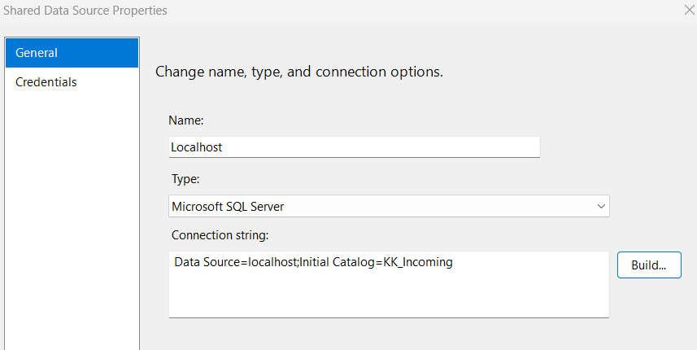

1. Create New Report
2. Select the Data Source created earlier as Shared Data Source.
3. Provide some select query in the Query String

Select * from [dbo].[Shopping_Trends]

1. Select Tabular
2. Select all the columns and click on Details

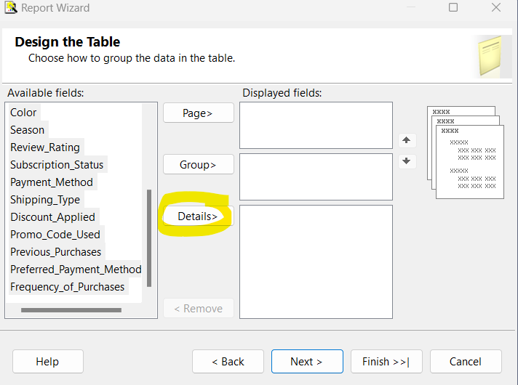 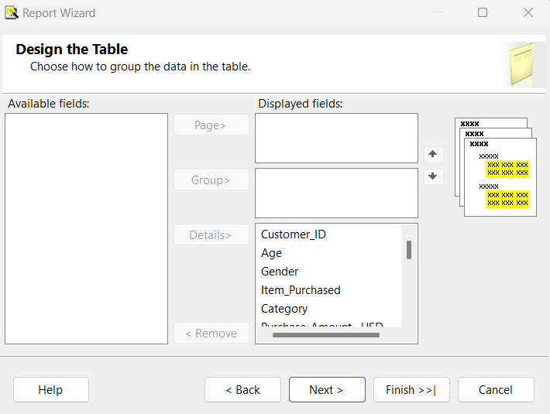

1. Click Next
2. Enter the Report Name
3. Click Finish
4. Now the report is created with all the columns as Report fields

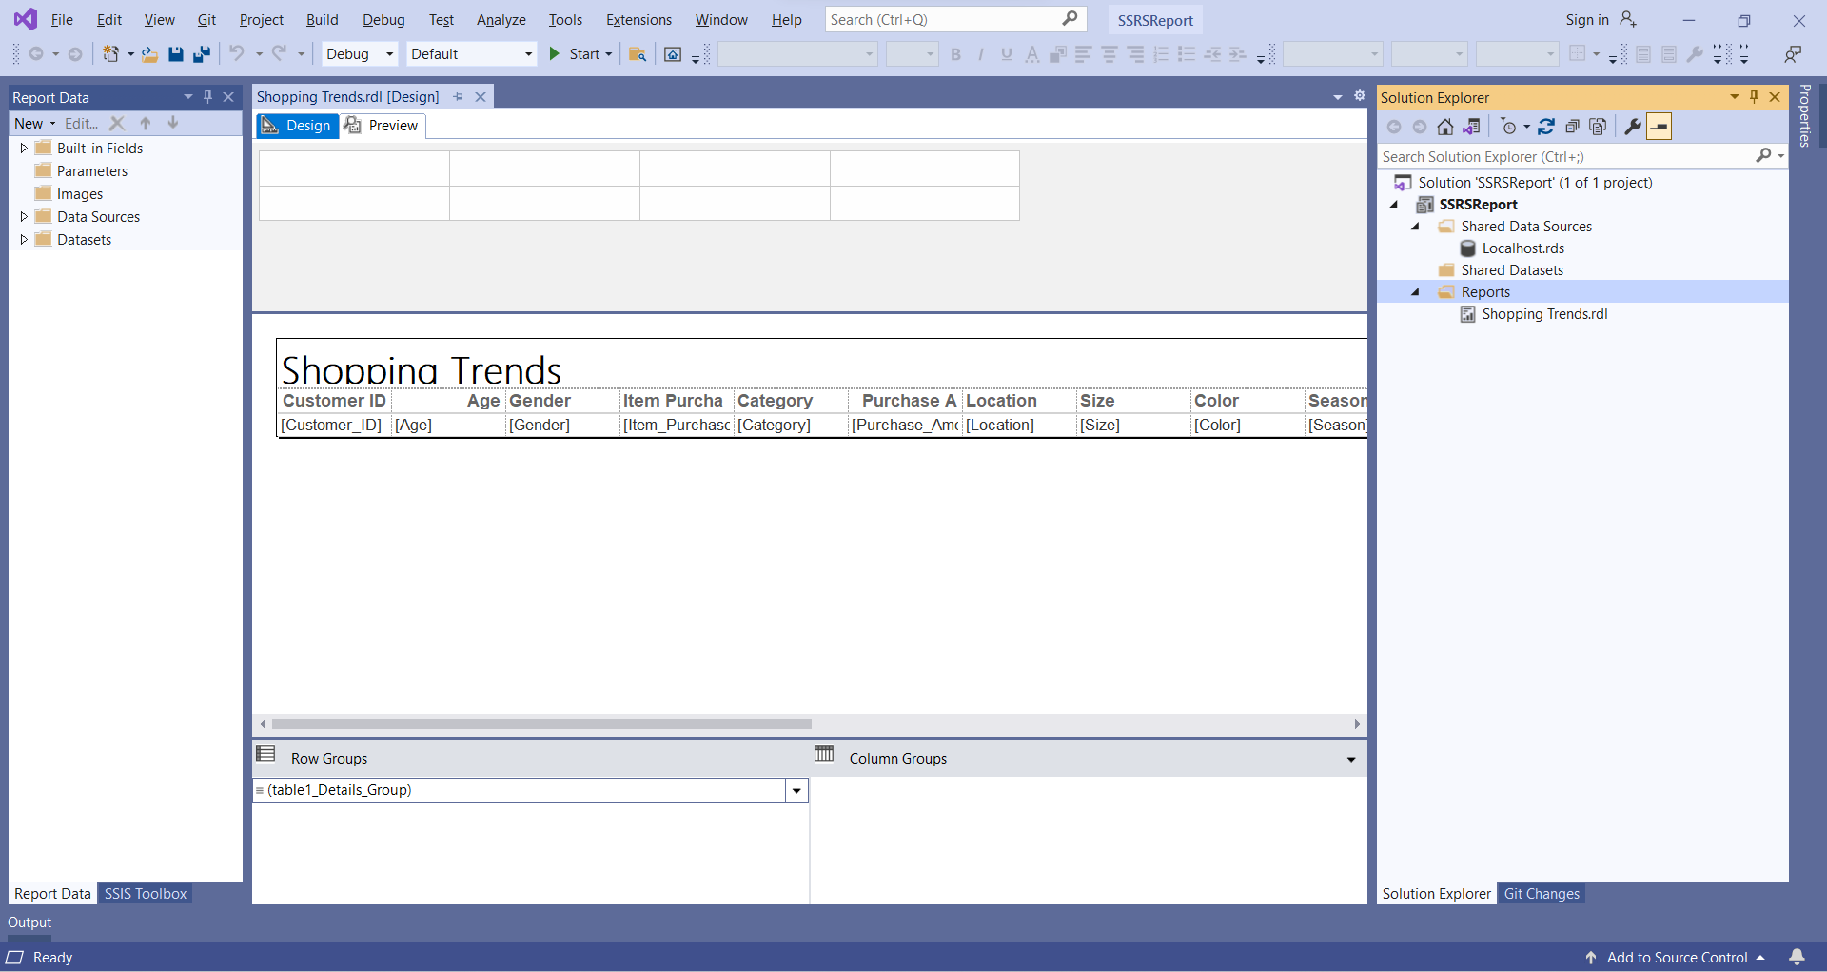

1. Now let’s add the Parameter to filter the report data based on Color Column
2. Right click on Parameter -> Add Parameter
3. Enter Name and Label and click OK

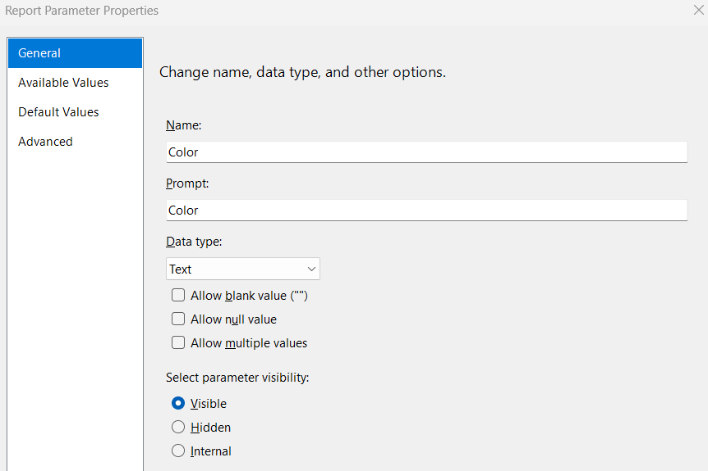

1. Double click on Dataset and select the Stored proc

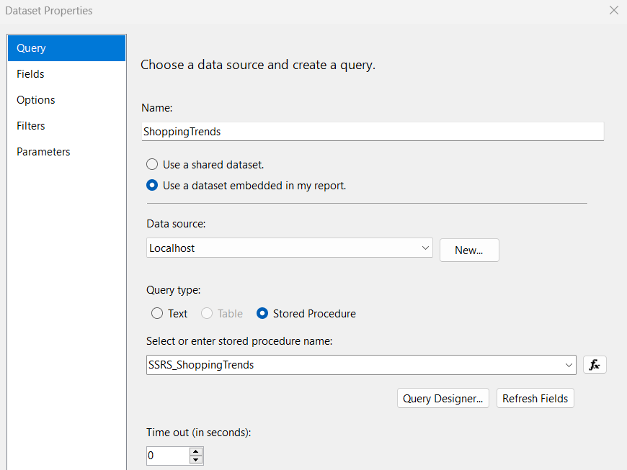

1. Click Parameters and select the param created from the drop down and click OK

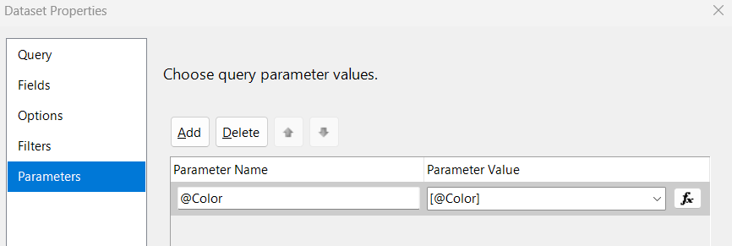

1. Create another dataset Color for the parameter drop down values.
2. Right click on Dataset -> Add Dataset. Enter the values as below.

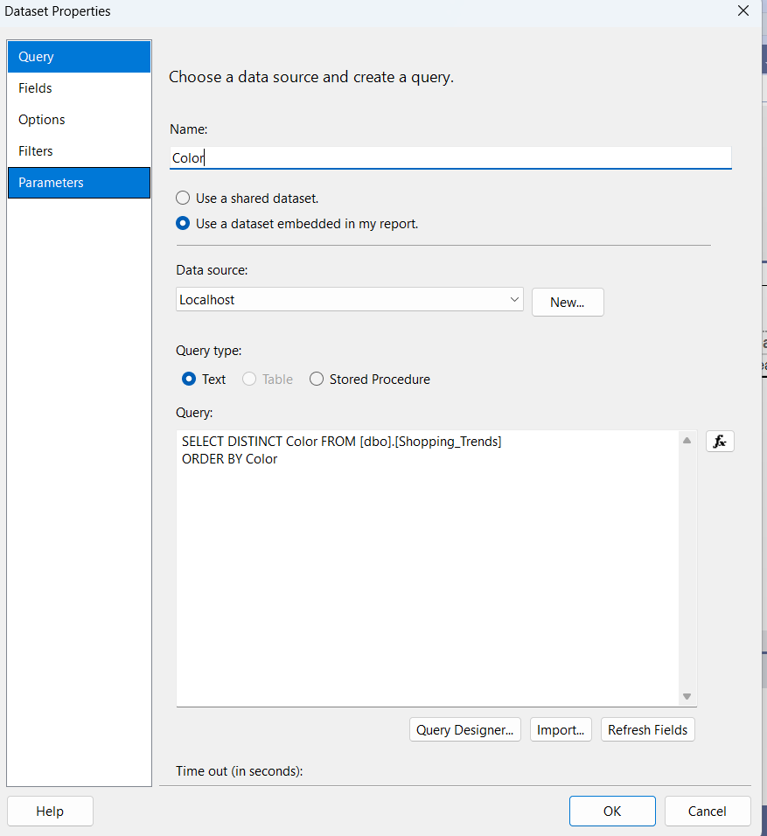

1. Select below values as in the snippet for Available Values.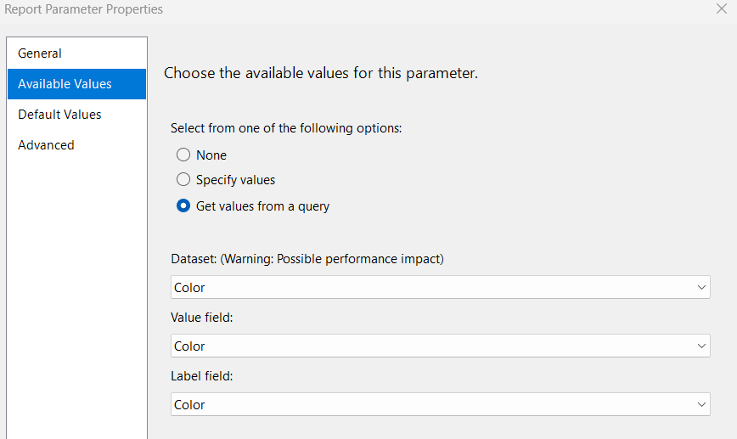
2. Now lets do some cosmetic changes to the report.
3. Select the title box, change Background color to Azure and middle aligned and Location to 6 inch.
4. Select the Tablix column headers and change the background color to Azure, middle aligned and size Width to 2 inch and location top to 0.7 inch.

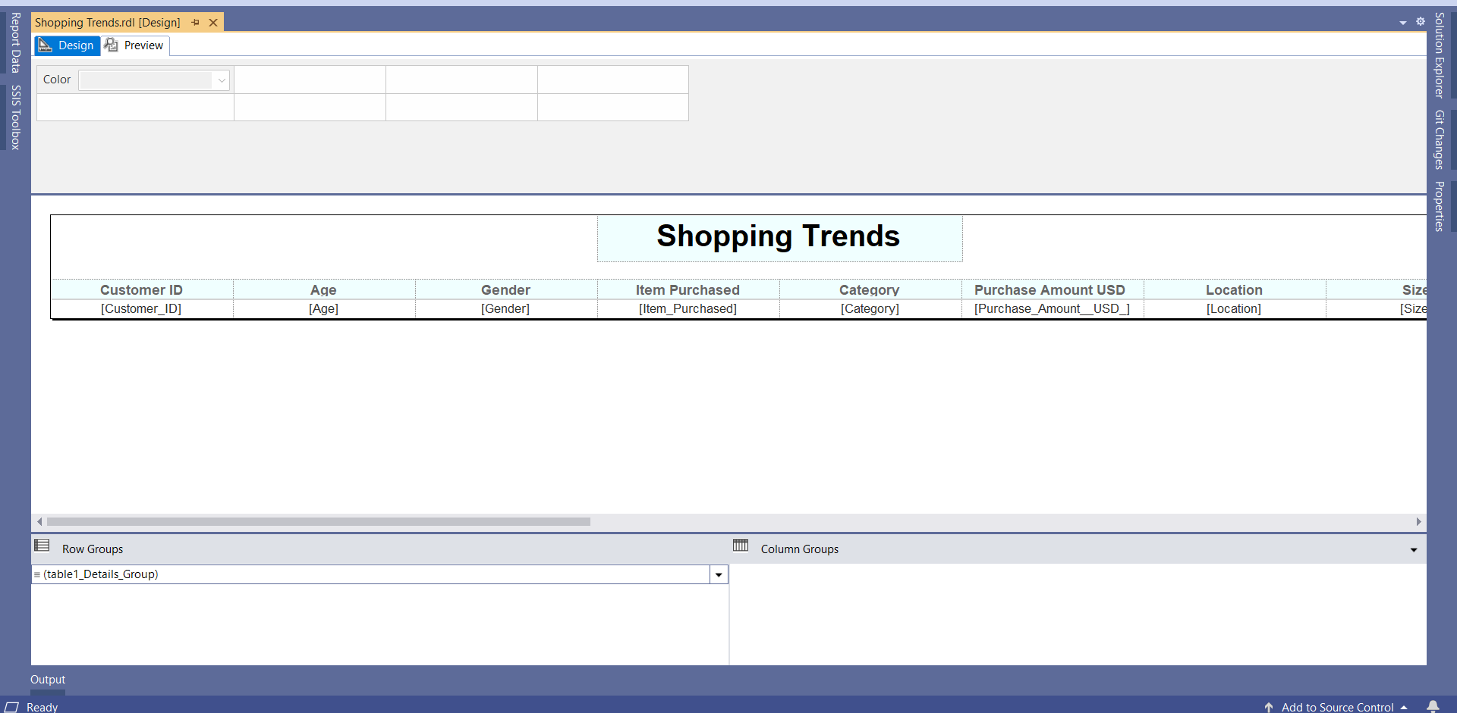

1. Now let’s preview the report. Sleect any color and click on View report.
2. Reports renders and displays the data where the color is Gold as below.

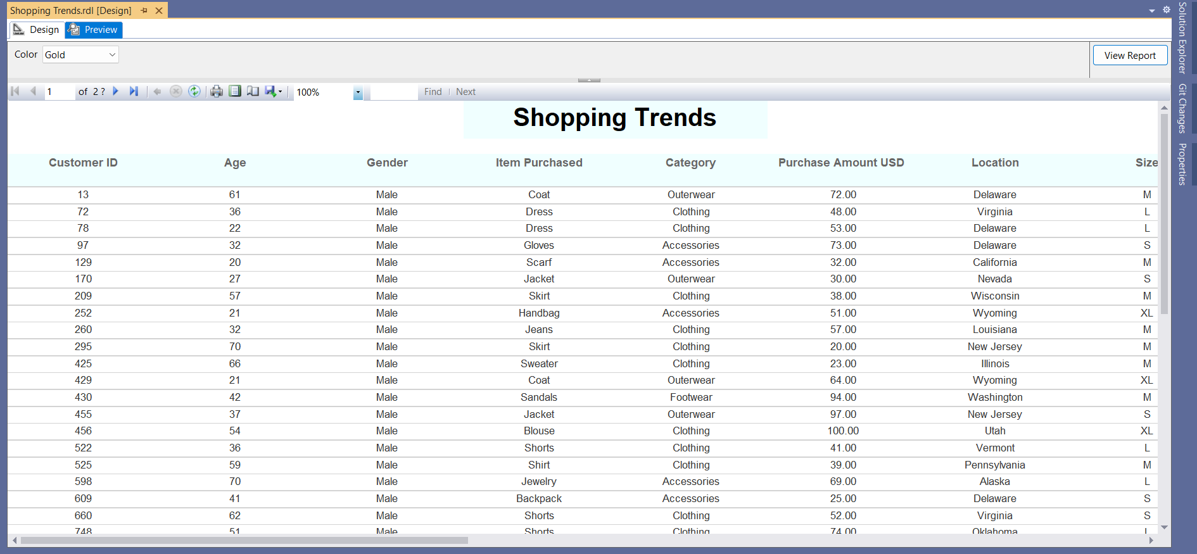

1. We can download the data in any format based on our requirement.

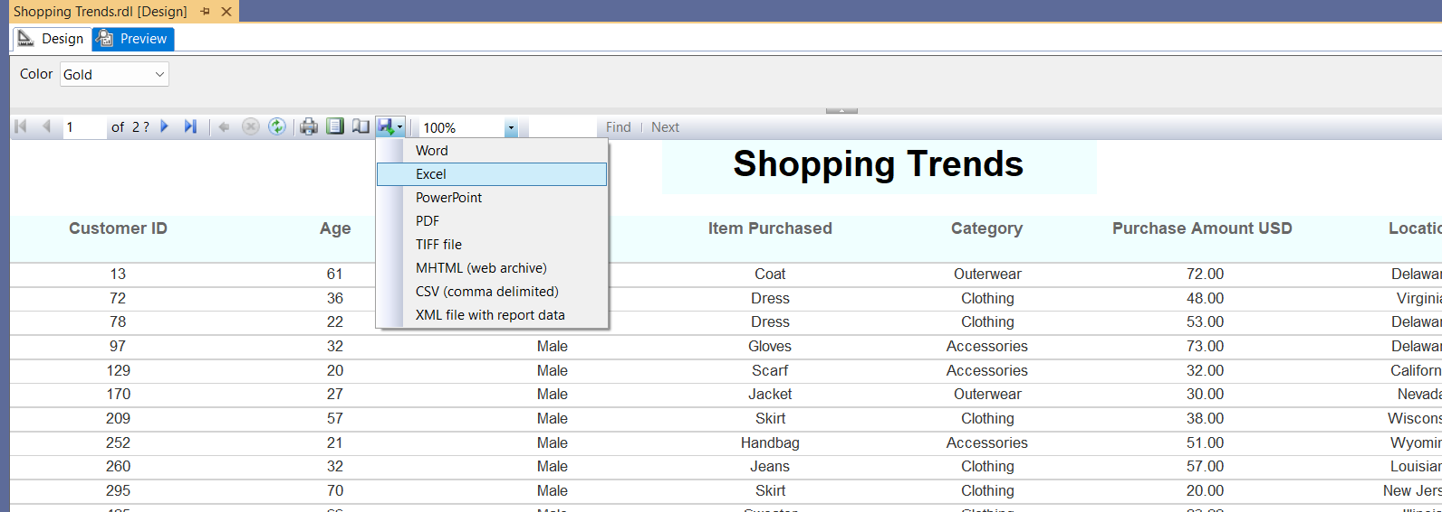

We have successfully created SSRS report.

You can find the complete solution and SSRS report file, Stored procedure creation script.

<https://github.com/kavyakotagiri/SSRS-Report-with-Filter>